- If you are trying to print your name, what happens if you leave out one of the quotation marks or both, and why?
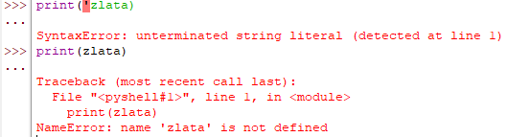
If you leave out one of the quotation marks, a program will think that the string never ended. If one of the quotation marks is missing, the program cannot understand when the string starts or ends. As Think Python confirms: “The quotation marks in the program mark the beginning and end of the text to be displayed; they don’t appear in the result” (Downey, 2015).
If you leave out both of the quotation marks, the program will think that ‘zlata’ is a variable name, and not a text. You cannot use print(…) without quotation for the string value type.
- What is the difference between * and ** operators in Python? Explain with the help of an example.
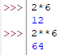2*6=12 / 2**6=2*2*2*2*2*2=64
As we see from example, * is a multiplication and ** is an exponentiation. Think Python approves this idea: “the operator ** performs exponentiation; that is, it raises a number to a power” (Downey, 2015).
- In Python, is it possible to display an integer like 09? Justify your answer.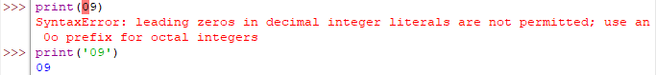
It is impossible to display an integer like 09 only if u will convert it to the string value type. Integers cannot start with 0, only if integer is 0.
- Run the commands type('67') and type(67). What is the difference in the output and why?
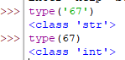
As we know from examples from Think Python: “2 is an integer, 42.0 is a floating-point number, and 'Hello, World!' is a string” (Downey, 2015), so it means in our case that 67 is an integer, and by putting it inside the quotation marks (‘67’), we convert it to the string value type. From this, we understand that there is a difference in the value type because our program reads ‘67’ as a text, and 67 as a number.

